We summarize the most commonly used Java language features and APIs in the textbook.

**Hello, World.**

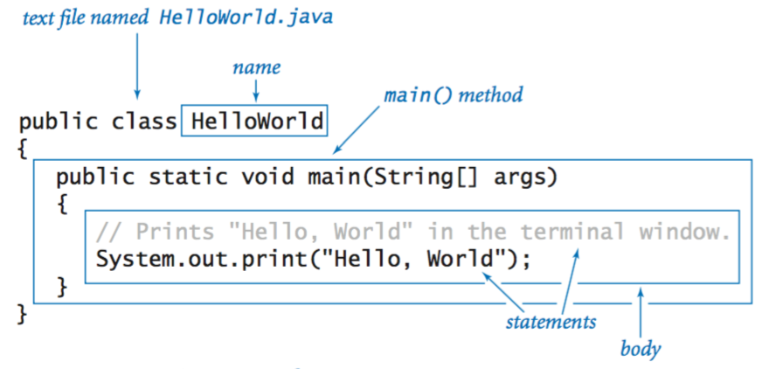

**Editing, compiling, and executing.**

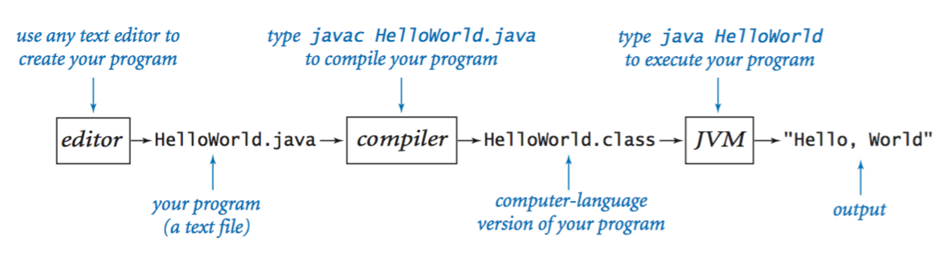

**Built-in data types.**

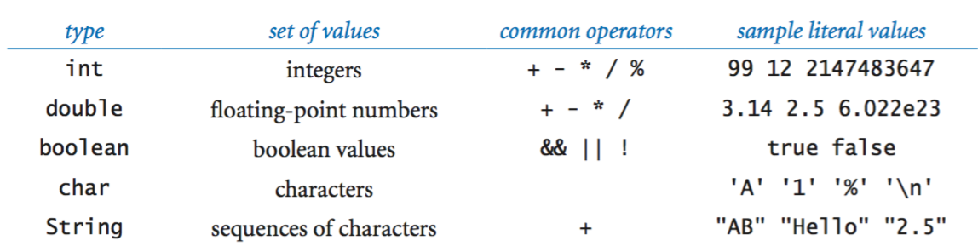

**Declaration and assignment statements.**

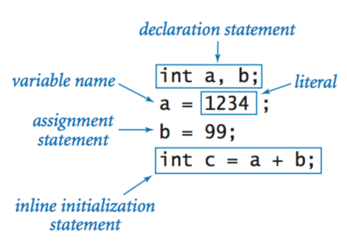

**Integers.**

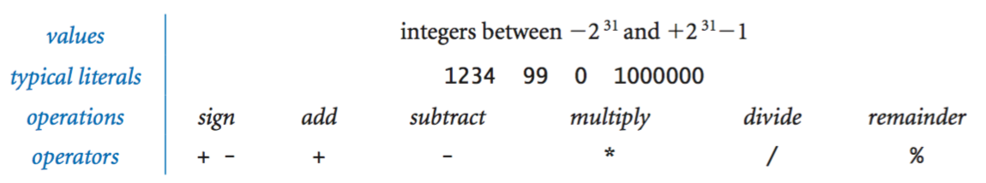

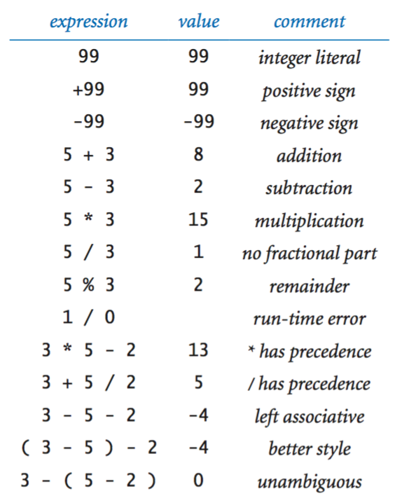

**Floating-point numbers.**

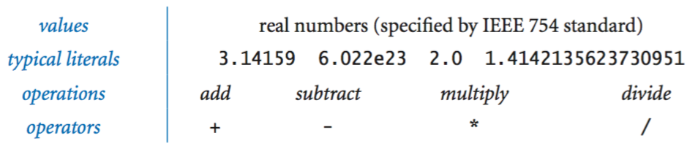

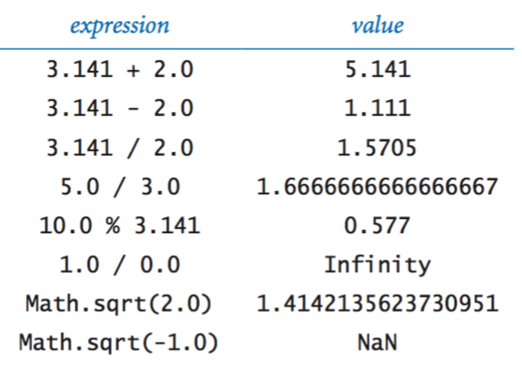

**Booleans.**

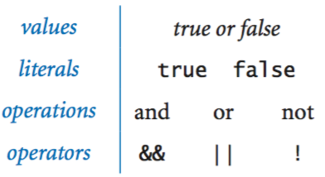

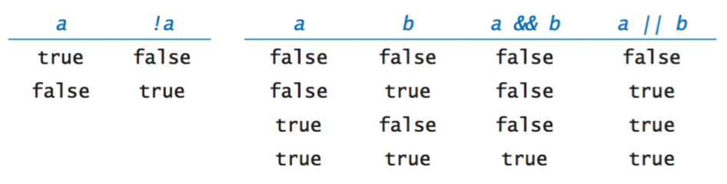

**Comparison operators.**

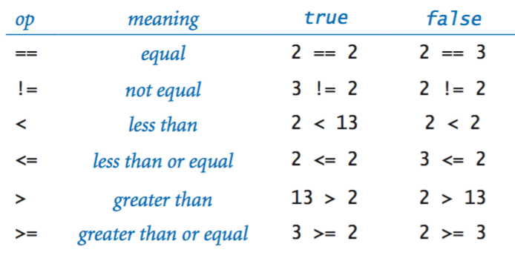

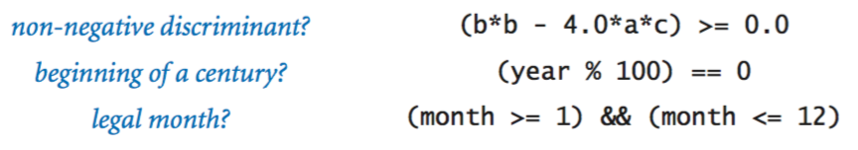

**Printing.**

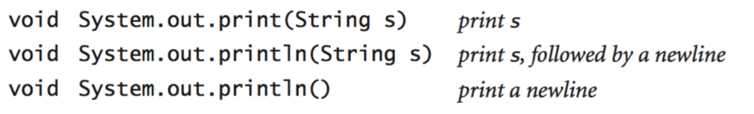

**Parsing command-line arguments.**

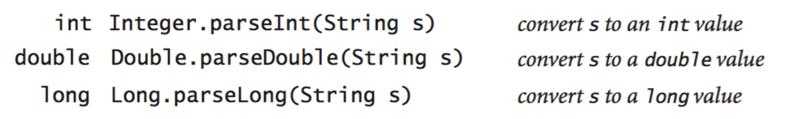

**Math library.**

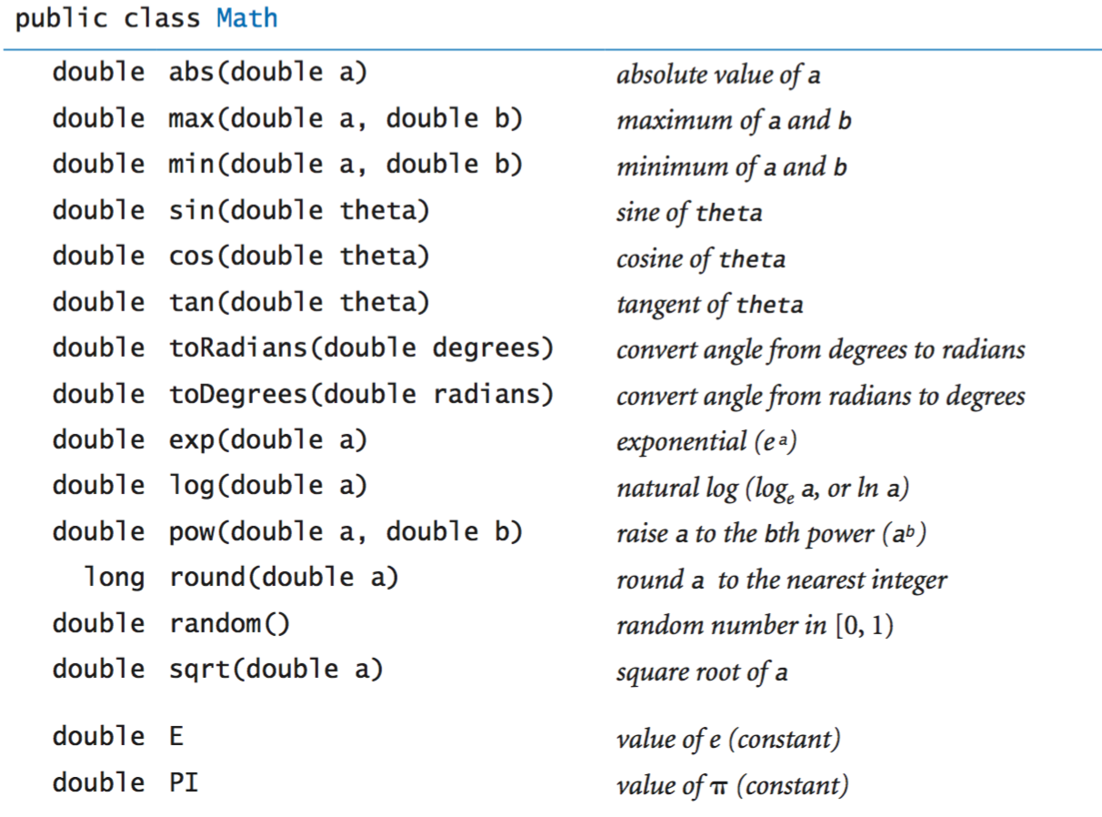

The full [java.lang.Math API](http://docs.oracle.com/javase/8/docs/api/java/lang/Math.html).

**Java library calls.**

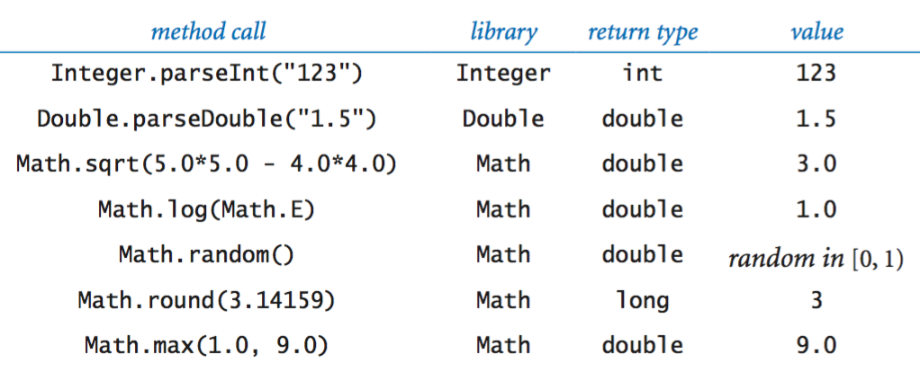

**Type conversion.**

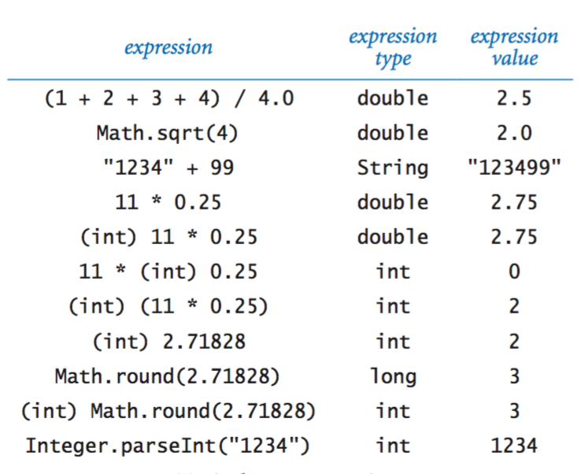

**Anatomy of an if statement.**

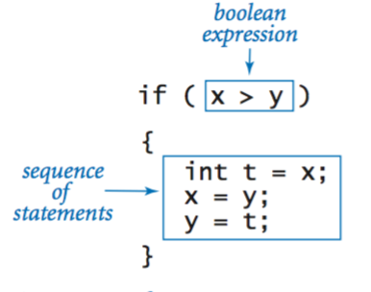

**If and if-else statements.**

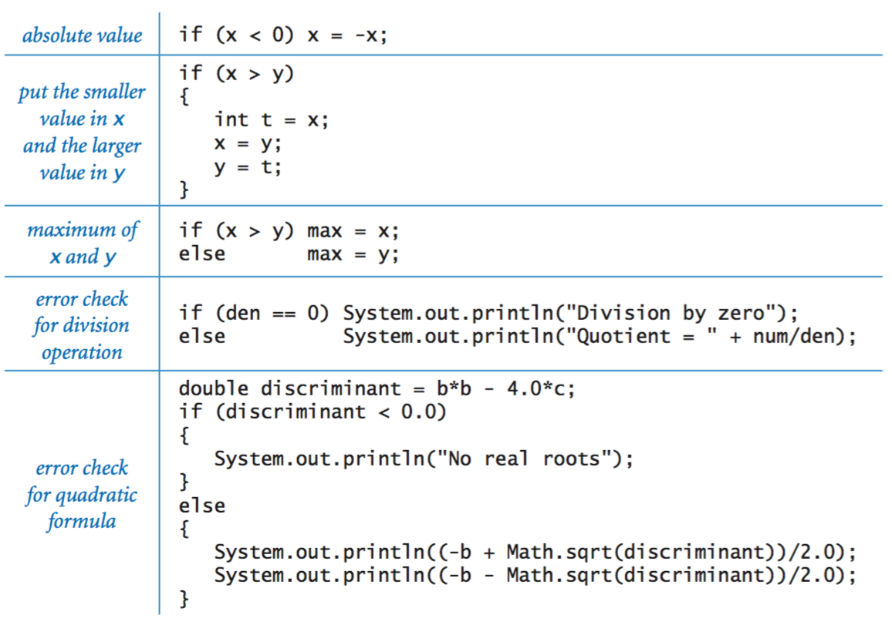

**Nested if-else statement.**

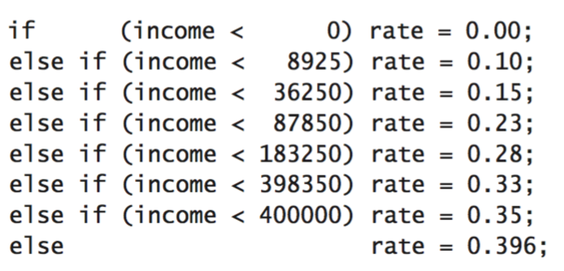

**Anatomy of a while loop.**

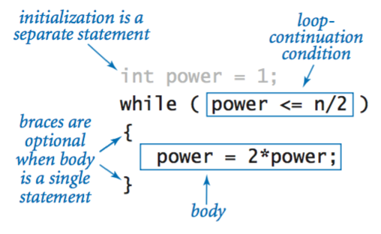

**Anatomy of a for loop.**

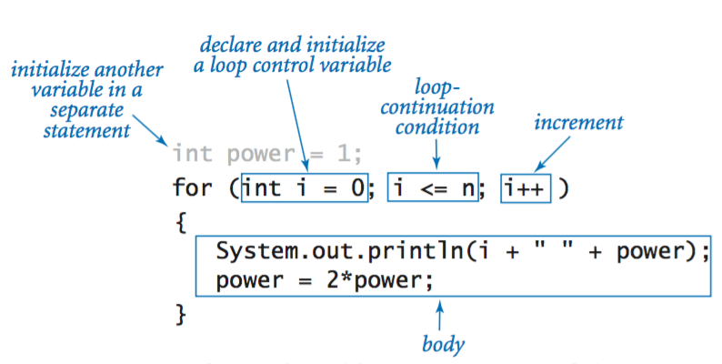

**Loops.**

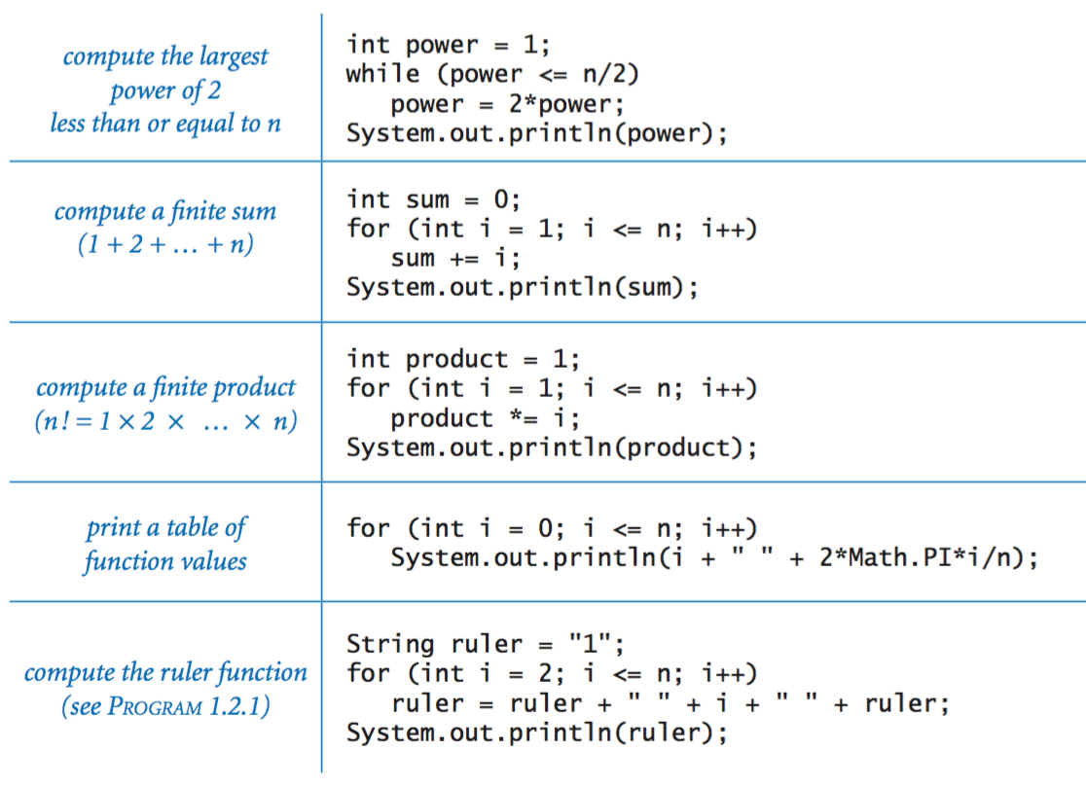

**Break statement.**

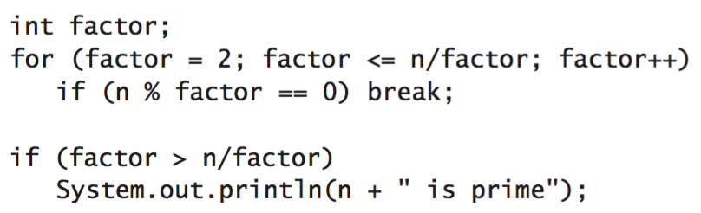

**Do-while loop.**

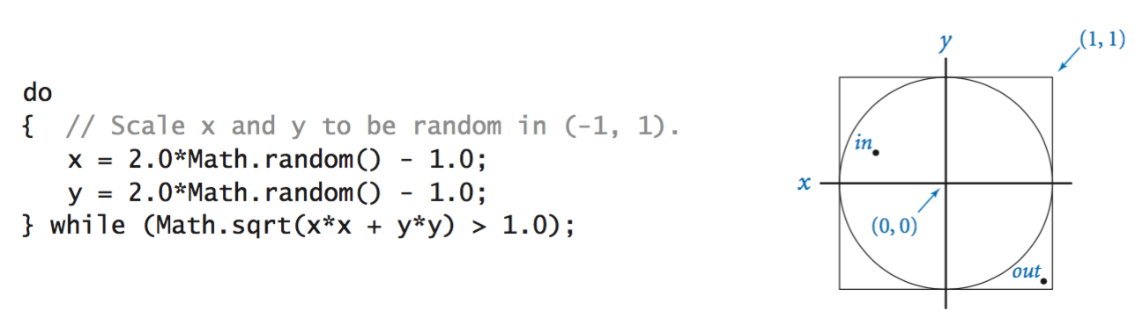

**Switch statement.**

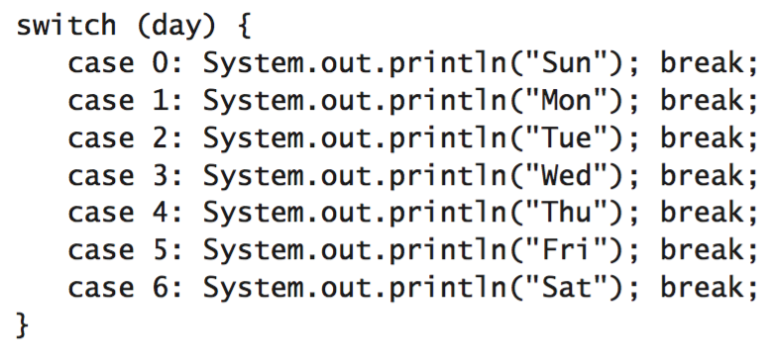

**Arrays.**

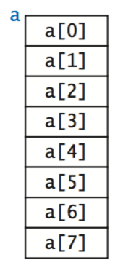

Inline array initialization.

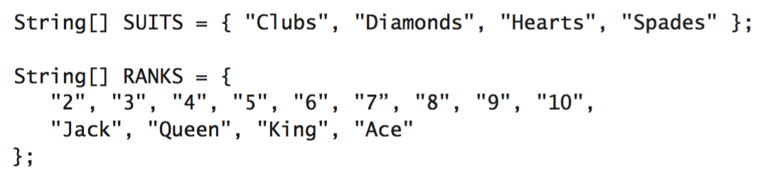

Typical array-processing code.

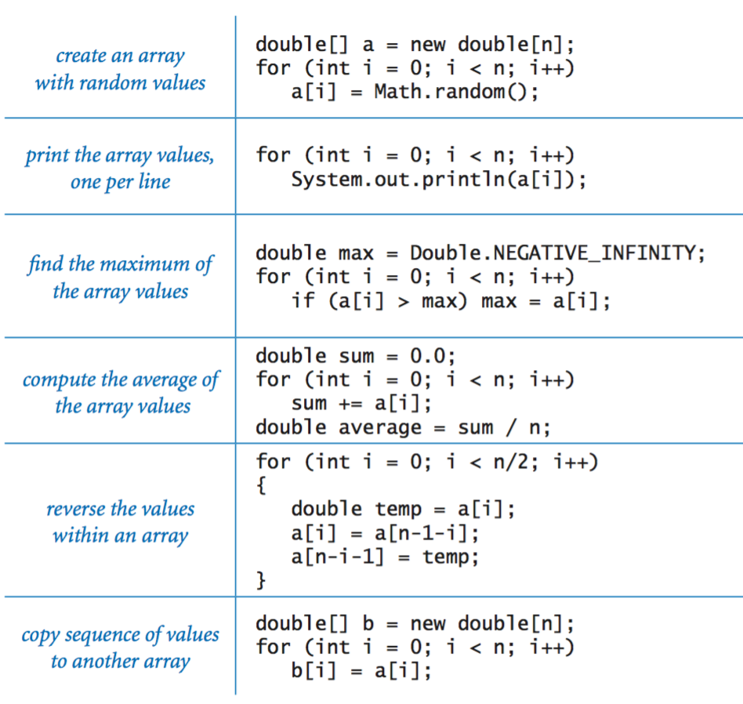

**Two-dimensional arrays.**

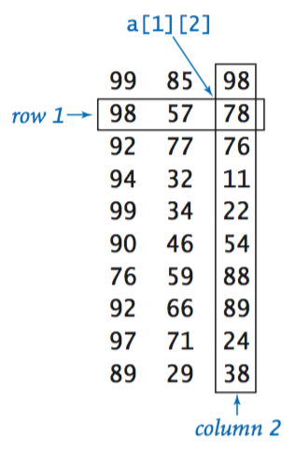

Inline initialization.

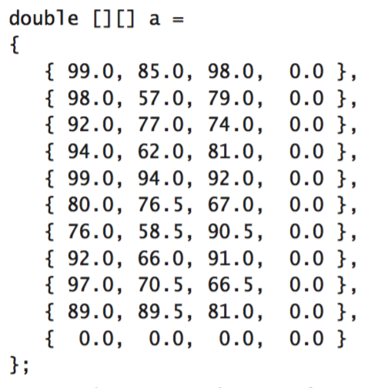

**Our standard output library.**

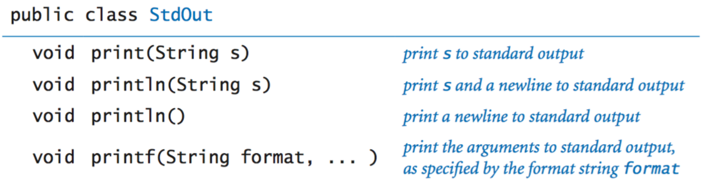

The full [StdOut API](https://introcs.cs.princeton.edu/java/stdlib/javadoc/StdOut.html).

**Formatted printing.**

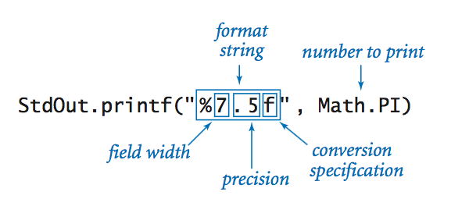

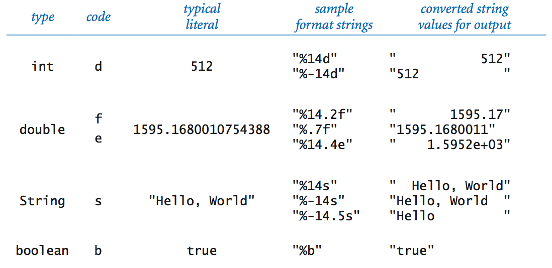

**Our standard input library.**



The full [StdIn API](https://introcs.cs.princeton.edu/java/stdlib/javadoc/StdIn.html).

**Our standard drawing library.**



The full [StdDraw API](https://introcs.cs.princeton.edu/java/stdlib/javadoc/StdDraw.html).

**Our standard audio library.**

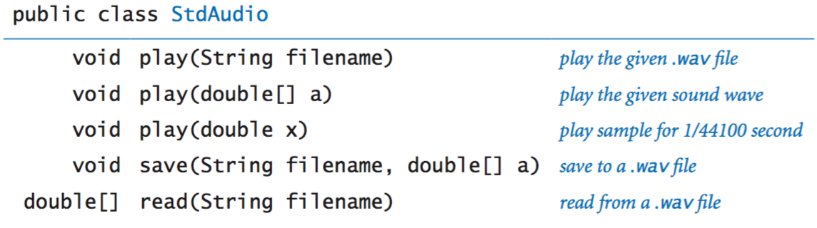

The full [StdAudio API](https://introcs.cs.princeton.edu/java/stdlib/javadoc/StdAudio.html).

**Command line.**

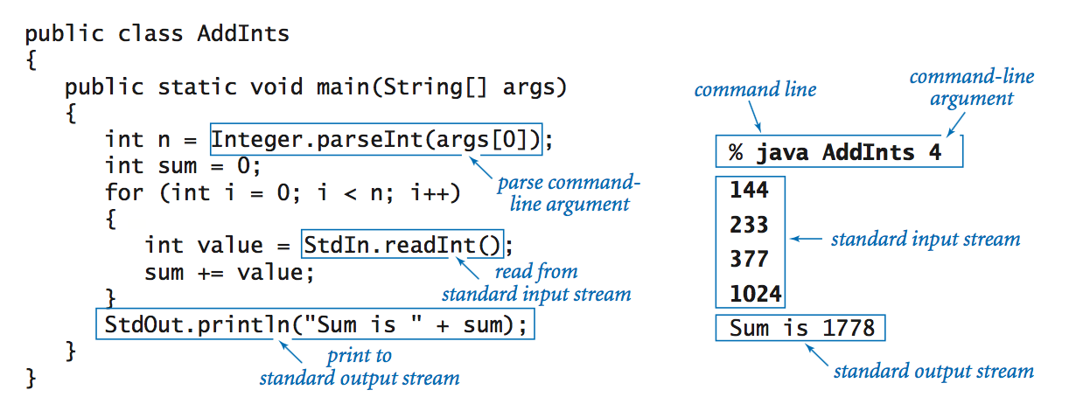

**Redirection and piping.**

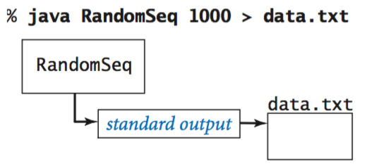 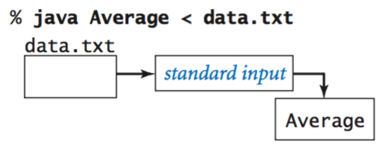

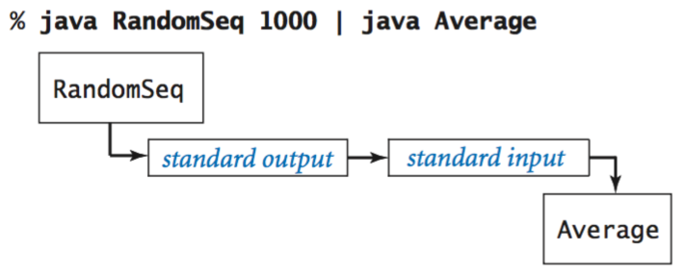

**Functions.**

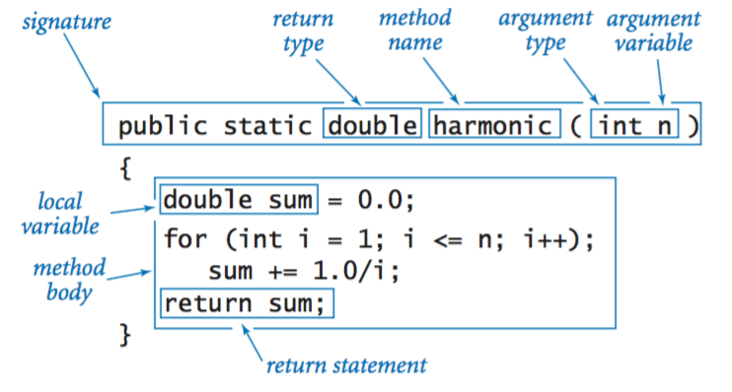

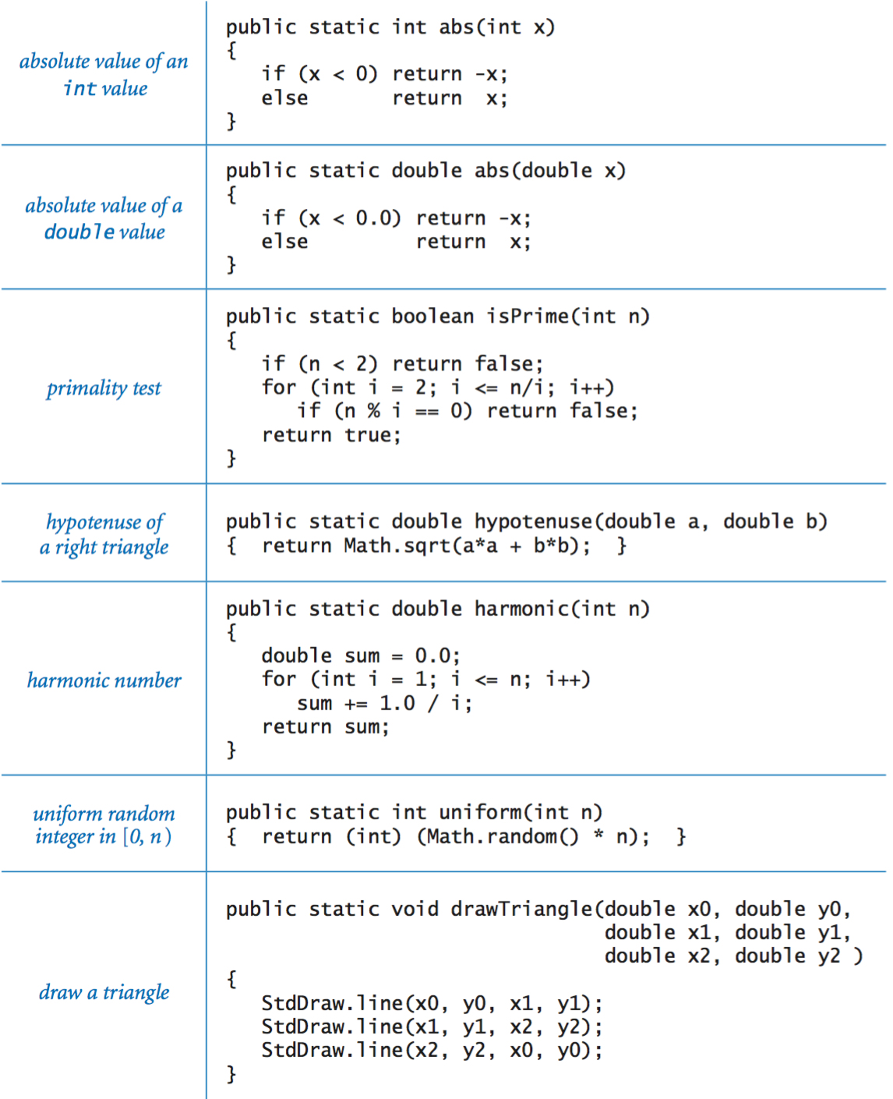

**Libraries of functions.**

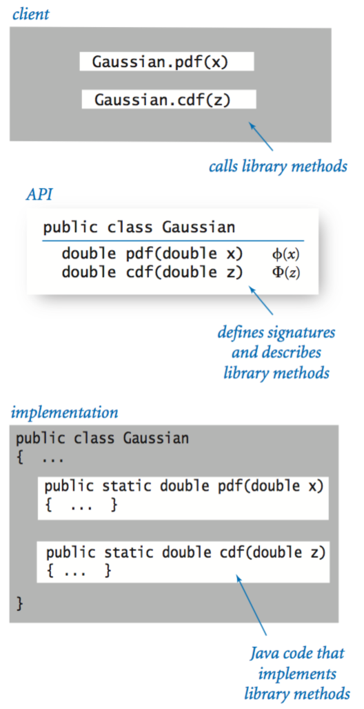

**Our standard random library.**

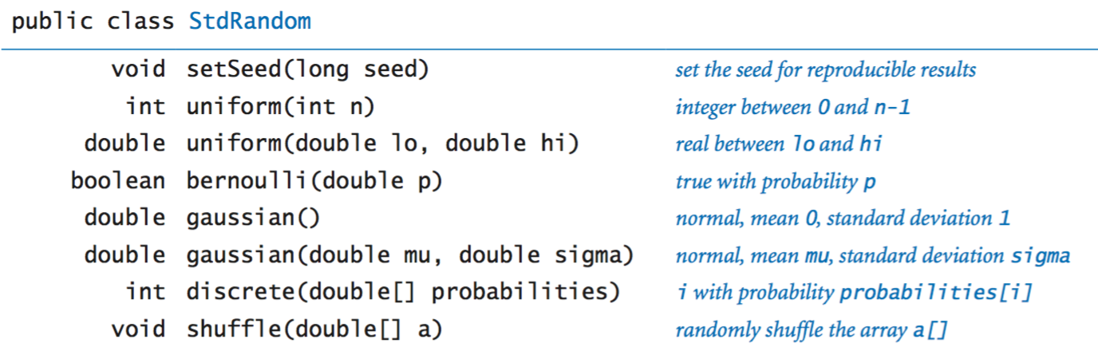

The full [StdRandom API](https://introcs.cs.princeton.edu/java/stdlib/javadoc/StdRandom.html).

**Our standard statistics library.**

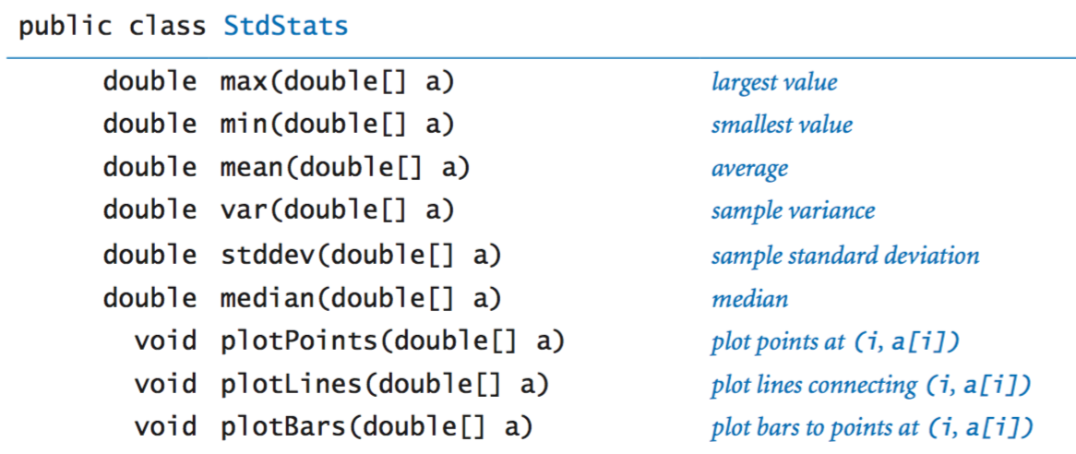

The full [StdStats API](https://introcs.cs.princeton.edu/java/stdlib/javadoc/StdStats.html).

**Using an object.**

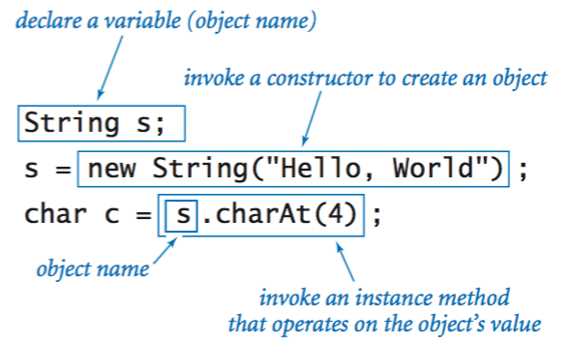

**Instance variables.**

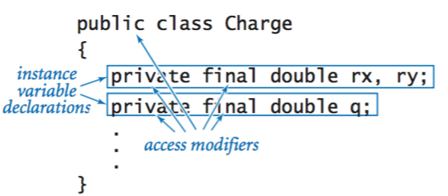

**Constructors.**

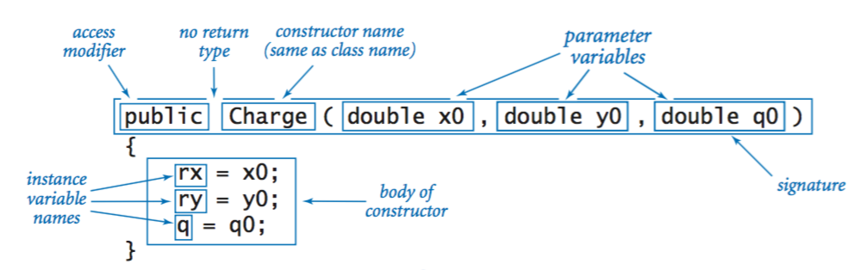

**Instance methods.**

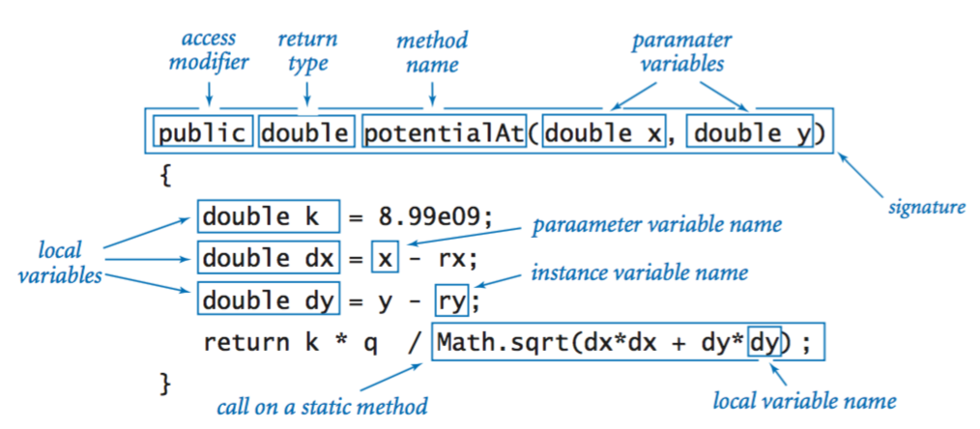

**Classes.**

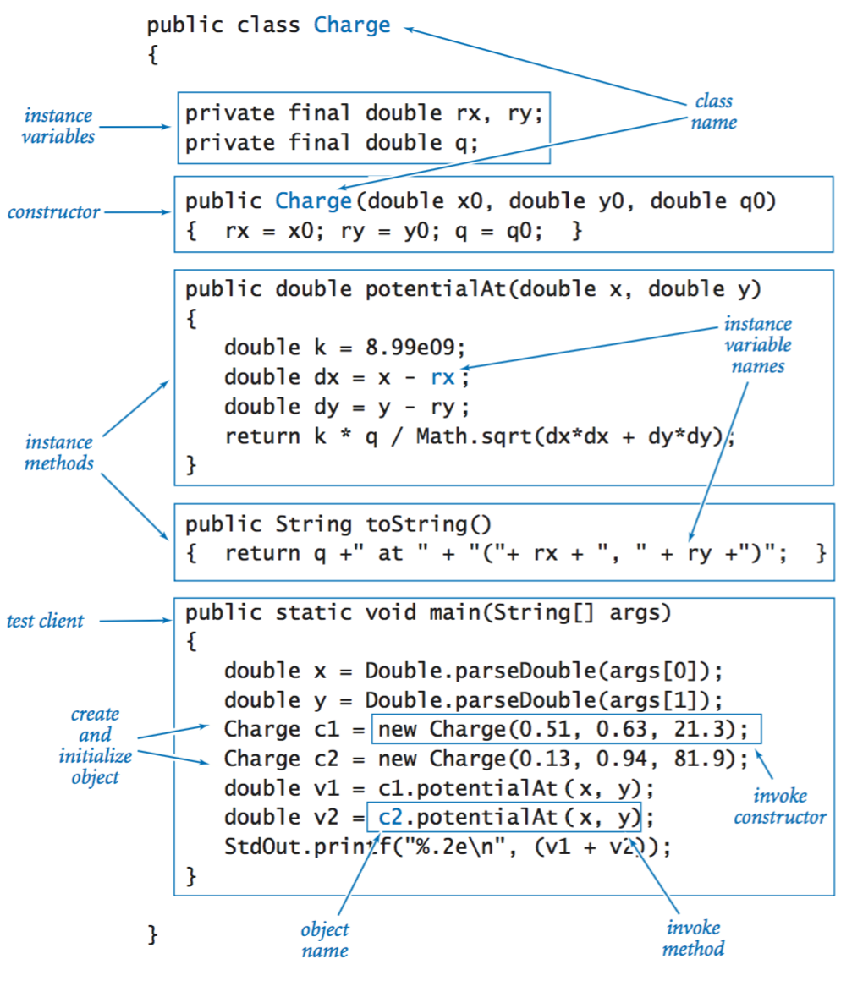

**Object-oriented libraries.**

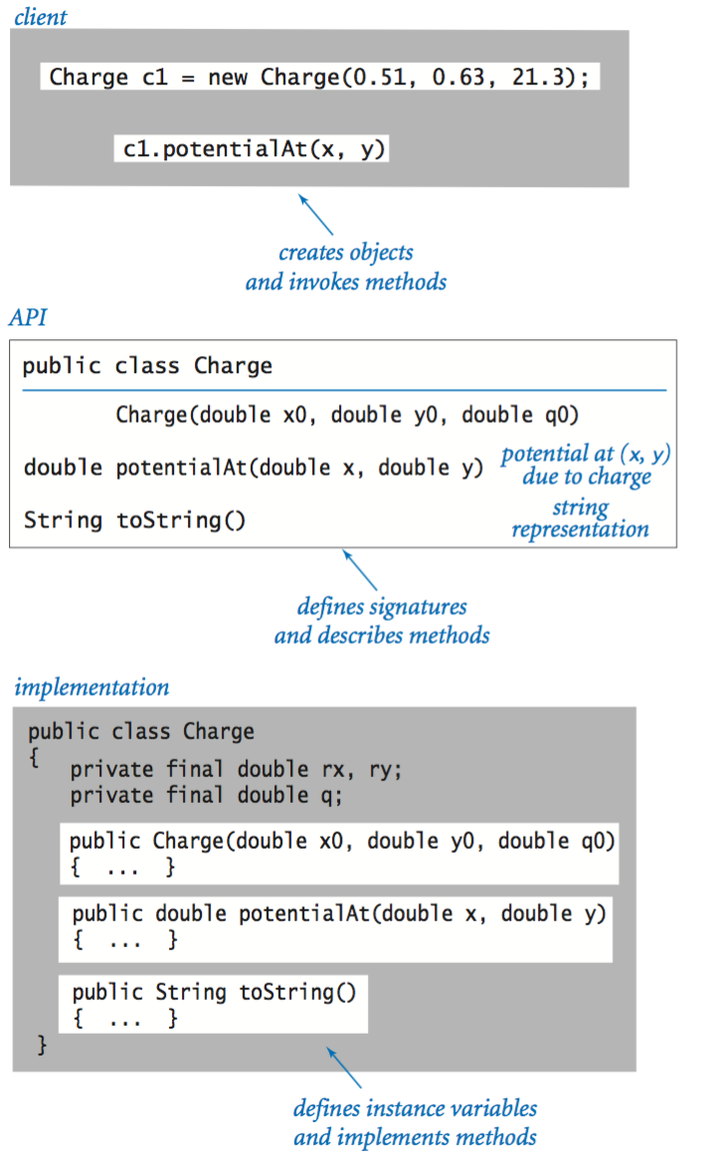

**Java's String data type.**

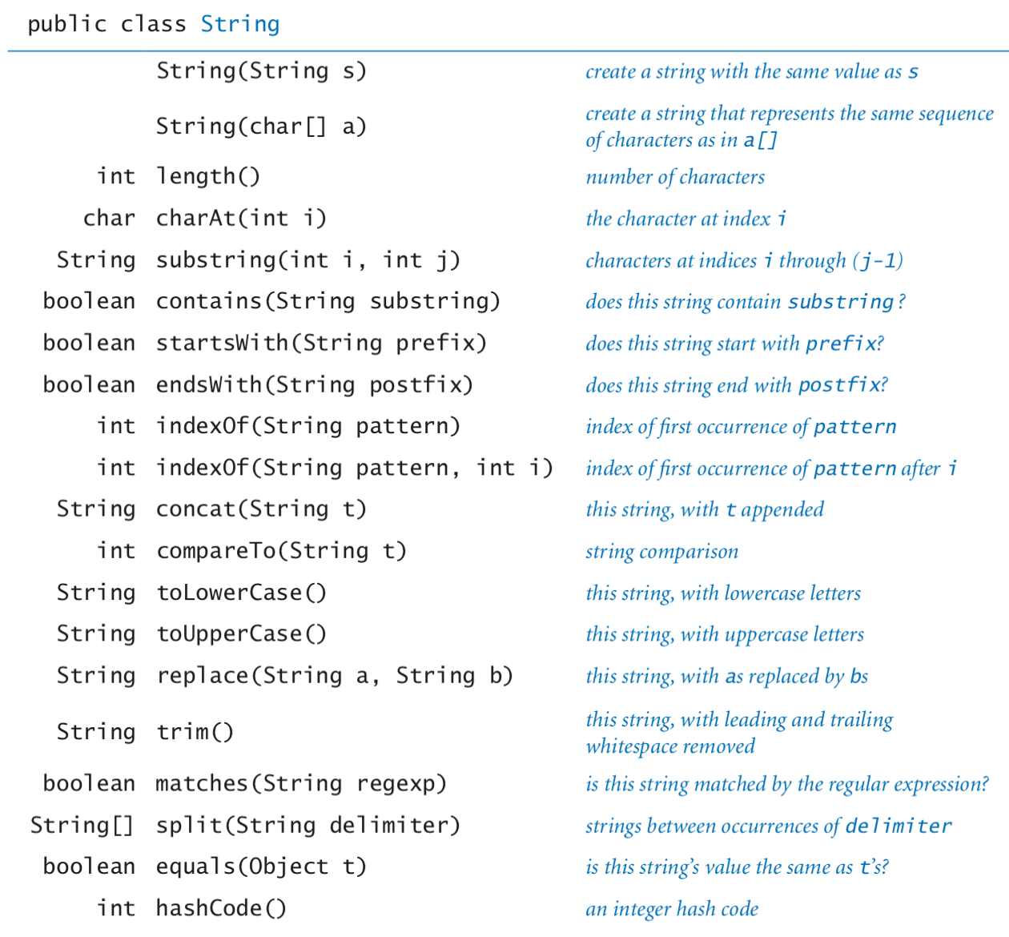

The full [java.lang.String API](http://docs.oracle.com/javase/6/docs/api/java/lang/String.html).

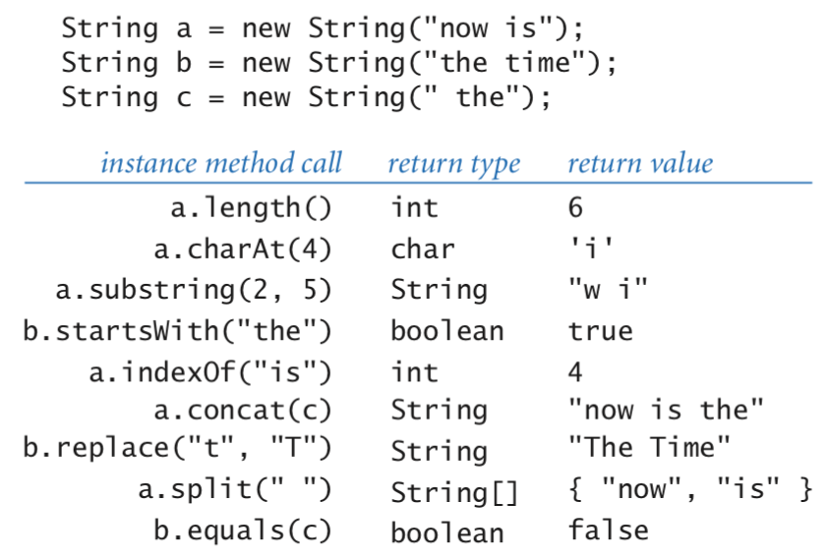

**Java's Color data type.**



The full [java.awt.Color API](http://docs.oracle.com/javase/6/docs/api/java/awt/Color.html).

**Our input library.**

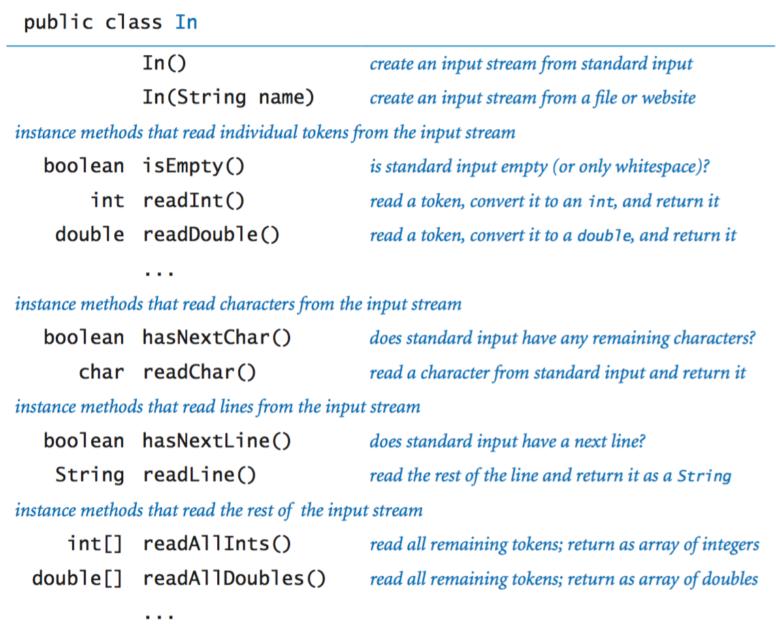

The full [In API](https://introcs.cs.princeton.edu/java/stdlib/javadoc/In.html).

**Our output library.**

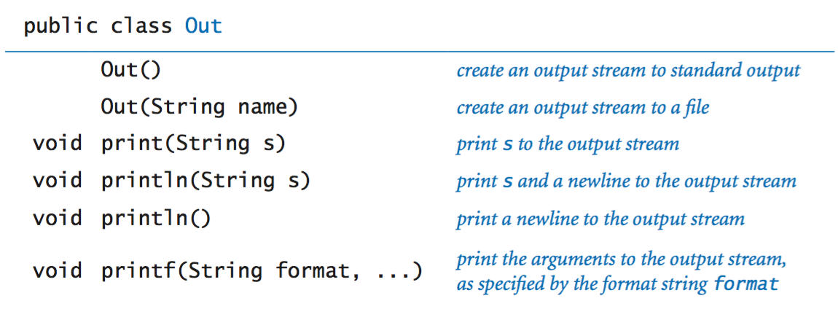

The full [Out API](https://introcs.cs.princeton.edu/java/stdlib/javadoc/Out.html).

**Our picture library.**

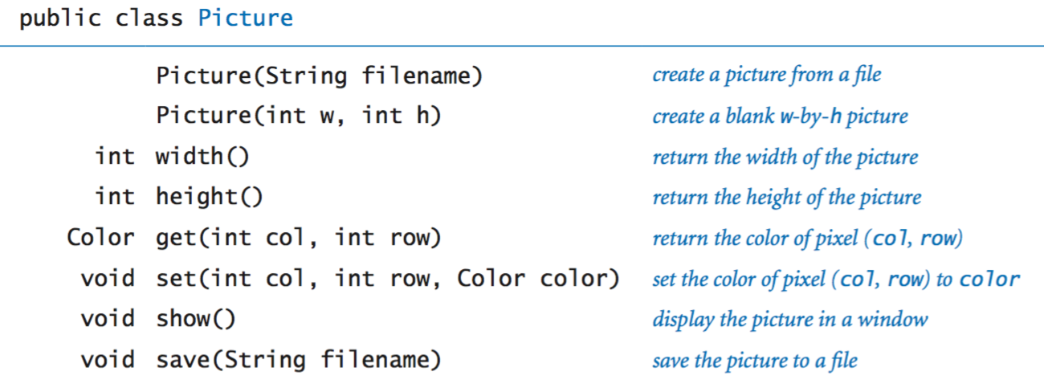

The full [Picture API](https://introcs.cs.princeton.edu/java/stdlib/javadoc/Picture.html).

**Our stack data type.**

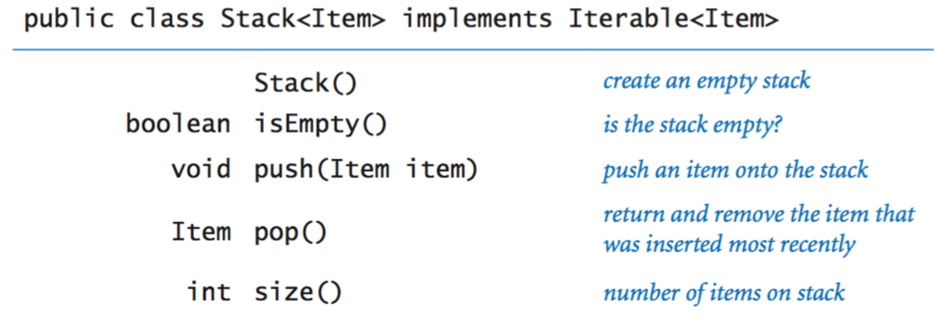

The full [Stack API](https://introcs.cs.princeton.edu/java/code/javadoc/Stack.html).

**Our queue data type.**

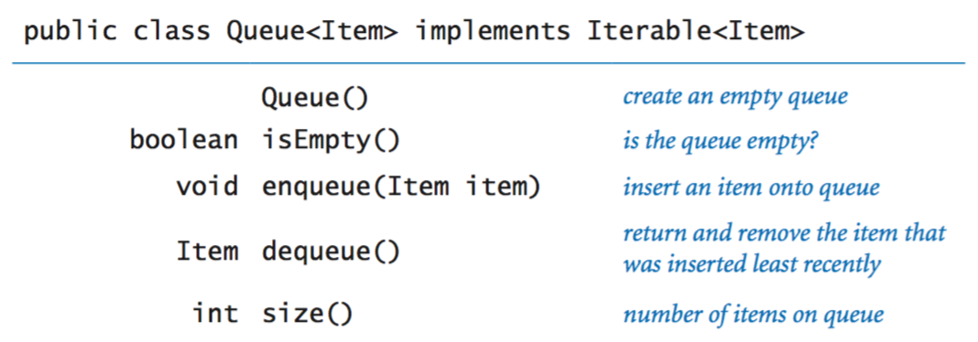

The full [Queue API](https://introcs.cs.princeton.edu/java/code/javadoc/Queue.html).

**Iterable.**

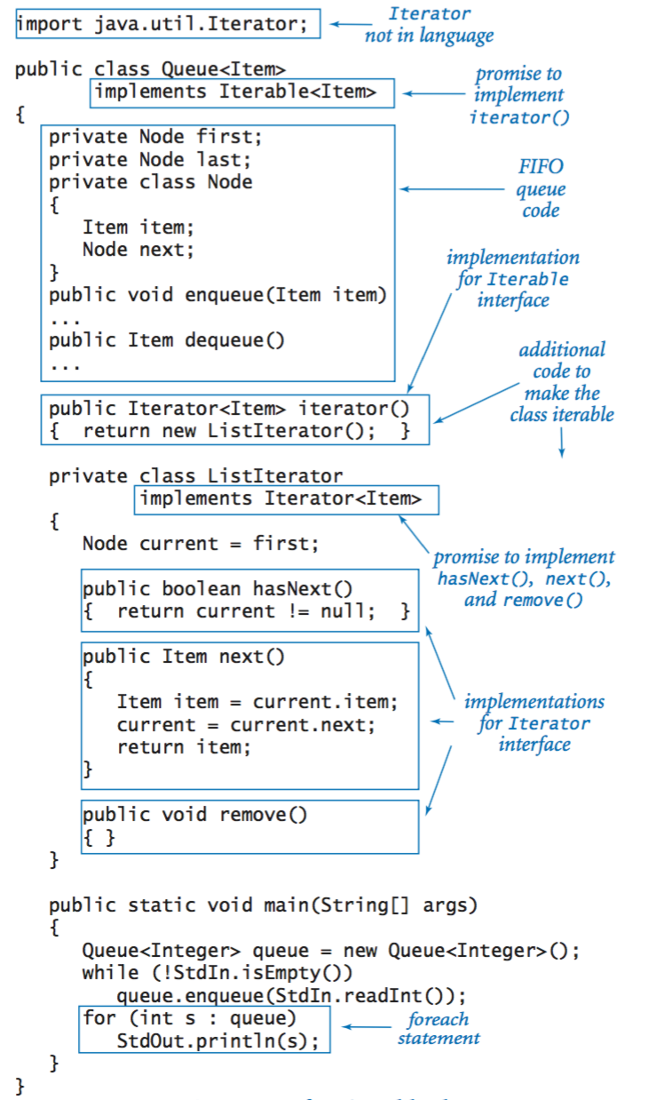

**Our symbol table data type.**

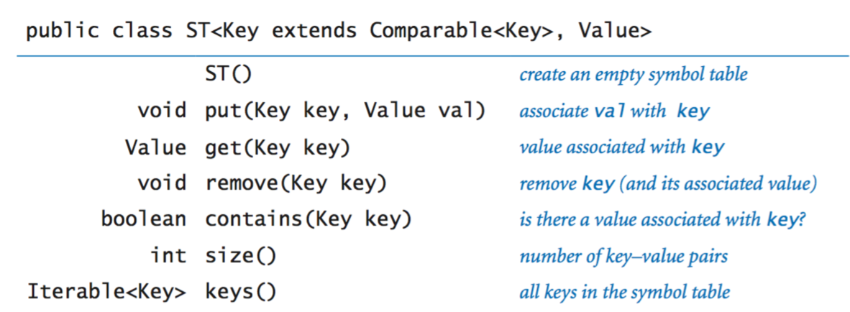

The full [ST API](https://introcs.cs.princeton.edu/java/code/javadoc/ST.html).

**Our set data type.**

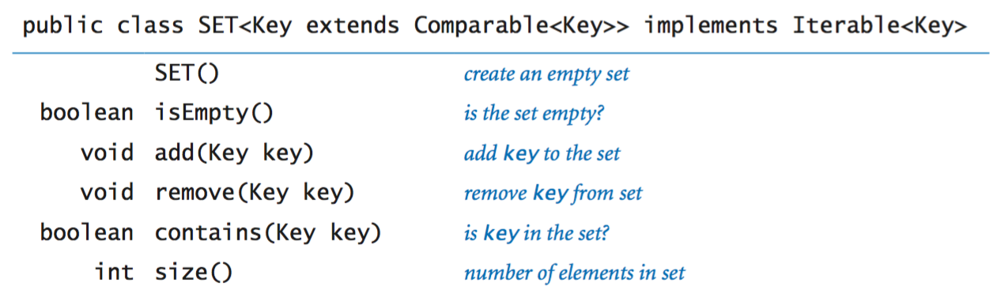

The full [SET API](https://introcs.cs.princeton.edu/java/code/javadoc/SET.html).

**Our graph data type.**

